Output Screenshots

Loading Data:

Fake News

True news

Preprocessing:

Visualization:

Removing unnecessary columns:

Count:

Monthly plot:

Shuffling the data and resetting the index values:

Remove duplicates:

Download Stopwords:

The number of times a specific word repeat in data:

Modeling:

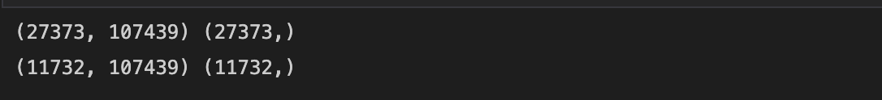

Logistic regression:

Data Accuracy:

